Scenario: Incremental Load & Automated Error Routing
Objective: Process a new daily batch of staging data containing existing updates, net-new records, and invalid data without duplicating records or breaking the pipeline.
New data inserted in source table:
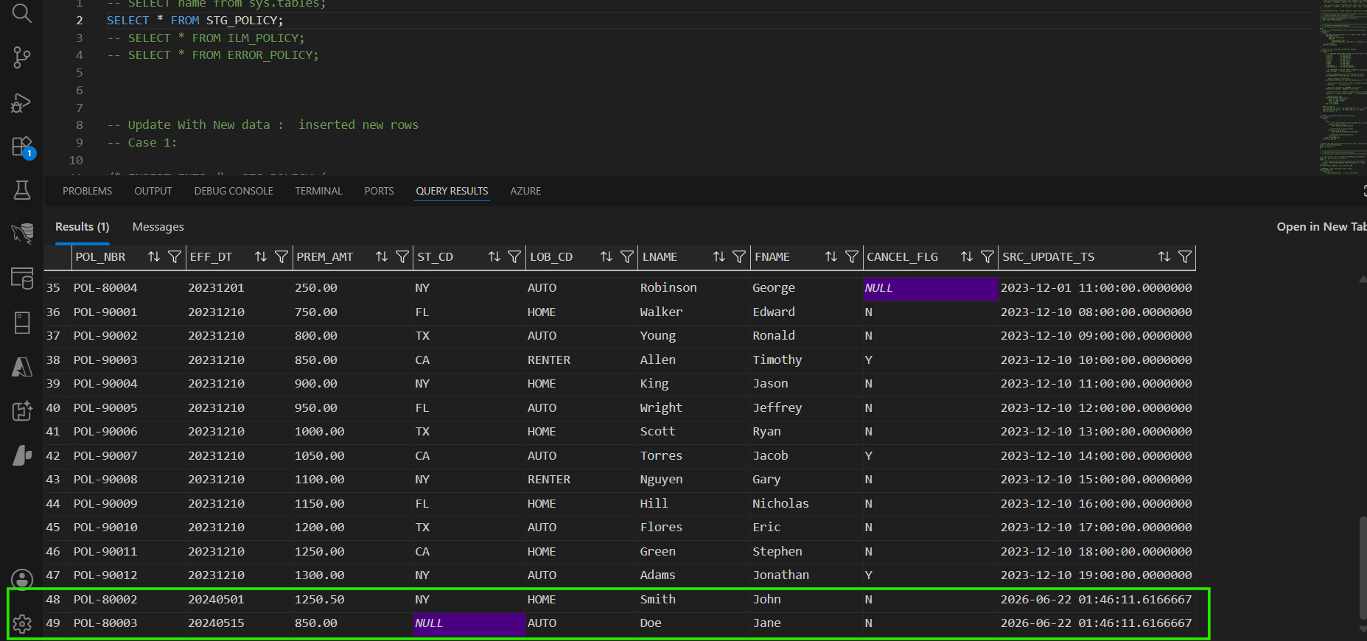

Pipeline Execution Results:
- Existing Records (Updates): 47 existing policies matched via the MERGE statement and were safely updated in place within the target table.
- Net-New Records (Inserts): 1 brand-new, valid policy (POL-80002) was identified by the MERGE statement and cleanly appended to dbo.ILM_POLICY.

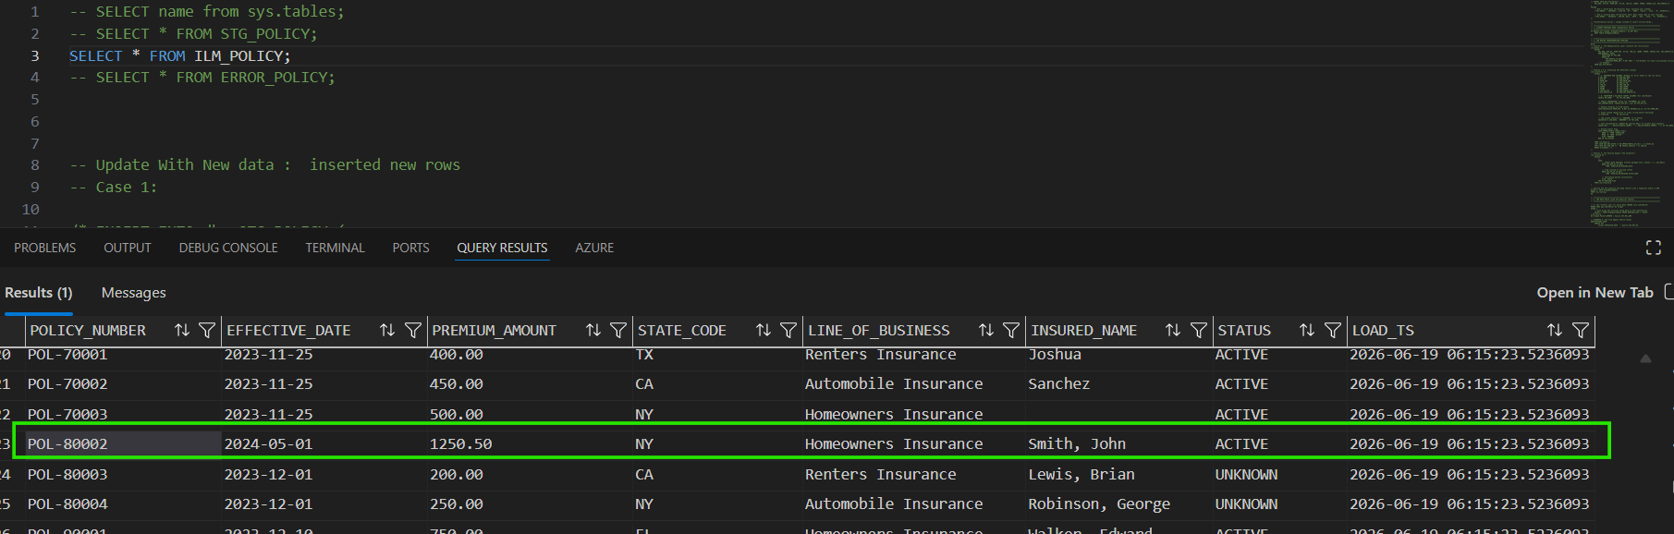
- Data Quality Quarantine: 1 invalid policy (POL-80003 with a NULL State Code) was intercepted by the routing engine, bypassed the target table entirely, and was successfully quarantined in dbo.ERROR_POLICY.
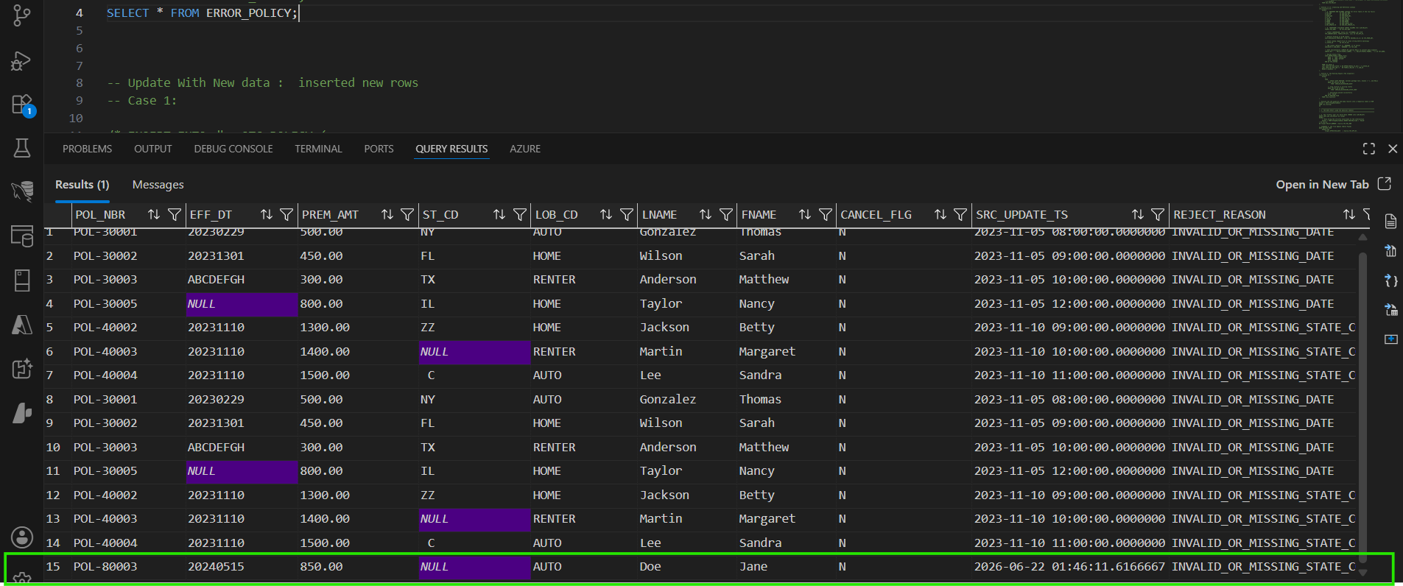

Utilized a decoupled architecture where data is first cleaned and validated in memory using CTEs. Valid records are loaded using a MERGE (UPSERT) statement acting as a traffic cop, while invalid records are routed directly to quarantine using a standard INSERT.
Scenario 2: The True Update (SCD Type 1 Overwrite)
Objective: Process an incoming record for an existing policy where the business data (e.g., Premium Amount) has changed, ensuring the target database reflects the most current state of the real world.
Updated Prem_AMT
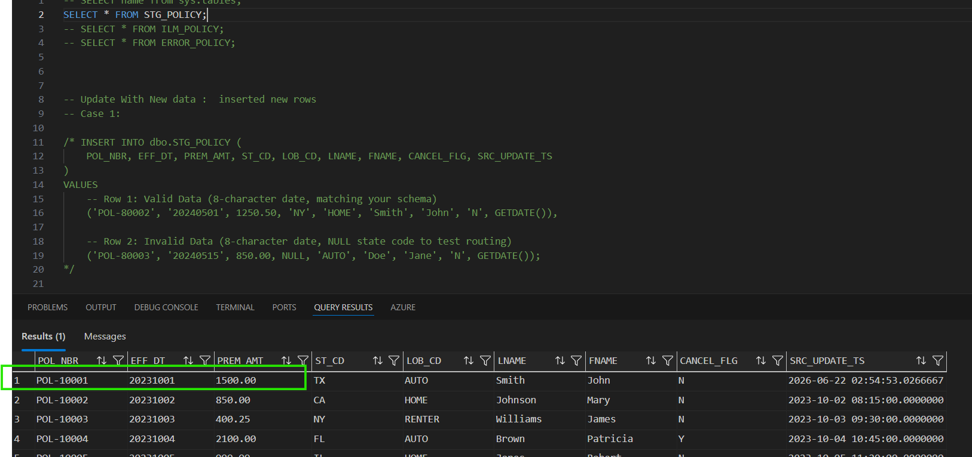
Pipeline Execution Results:
- Modified Record: 1 existing policy (POL-10001) was successfully identified by the pipeline. The old premium of $1,200.50 was permanently overwritten in place with the updated $1,500.00 premium.
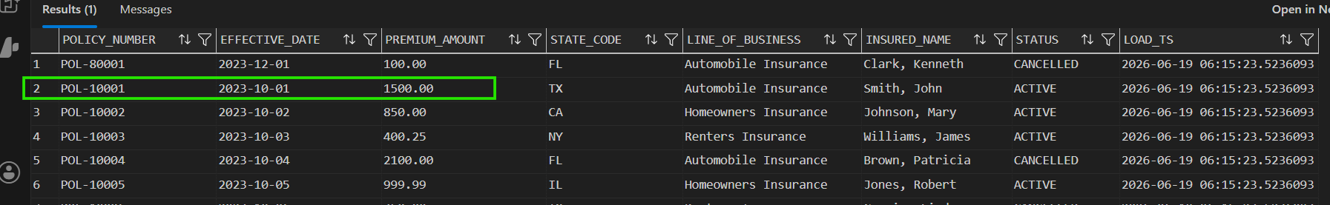
- Unchanged Records (Idempotency): The remaining valid policies were processed through the batch. The system safely matched them and performed a "dummy update," leaving their existing values perfectly intact without duplicating rows.
- No Historical Bloat: Because architecture deliberately follows a Slowly Changing Dimension (SCD) Type 1 pattern, the database optimized storage by prioritizing the current state over preserving historical ledgers.

Scenario 3: The Exact Duplicate (Compute Optimization)
Objective: Prevent the pipeline from processing redundant updates when incoming staging data is an edge-to-edge perfect match with the existing target data.
Pipeline Execution Results:
- Bypassed Records: Incoming policies that perfectly matched the existing records in the target table were identified and cleanly ignored.
- Zero Write Operations: The optimized pipeline executed with (0 rows affected) for these specific rows, eliminating unnecessary database I/O, compute waste, and index fragmentation.

Change requirements regarding merge:
MERGE INTO dbo.ILM_POLICY AS Target
USING (
SELECT * FROM #TempRoutedData WHERE ROUTING_FLAG = 'VALID'
) AS Source
ON Target.POLICY_NUMBER = Source.TGT_POL_NBR
WHEN MATCHED AND (
Target.EFFECTIVE_DATE <> Source.TGT_EFF_DT OR
Target.PREMIUM_AMOUNT <> Source.TGT_PREM_AMT OR
Target.STATE_CODE <> Source.TGT_ST_CD OR
Target.LINE_OF_BUSINESS <> Source.TGT_LOB OR
Target.INSURED_NAME <> Source.TGT_NAME OR
Target.STATUS <> Source.TGT_STATUS
)
THEN
UPDATE SET
Target.EFFECTIVE_DATE = Source.TGT_EFF_DT,
Target.PREMIUM_AMOUNT = Source.TGT_PREM_AMT,
Target.STATE_CODE = Source.TGT_ST_CD,
Target.LINE_OF_BUSINESS = Source.TGT_LOB,
Target.INSURED_NAME = Source.TGT_NAME,
Target.STATUS = Source.TGT_STATUS,
Target.LOAD_TS = GETDATE()
WHEN NOT MATCHED BY TARGET THEN
INSERT (
POLICY_NUMBER, EFFECTIVE_DATE, PREMIUM_AMOUNT, STATE_CODE,
LINE_OF_BUSINESS, INSURED_NAME, STATUS, LOAD_TS
)
VALUES (
Source.TGT_POL_NBR, Source.TGT_EFF_DT, Source.TGT_PREM_AMT, Source.TGT_ST_CD,
Source.TGT_LOB, Source.TGT_NAME, Source.TGT_STATUS, GETDATE()
);
INSERT INTO dbo.ERROR_POLICY (
POL_NBR, EFF_DT, PREM_AMT, ST_CD, LOB_CD, LNAME, FNAME,
CANCEL_FLG, SRC_UPDATE_TS, REJECT_REASON
)
SELECT
RAW_POL_NBR, RAW_EFF_DT, RAW_PREM_AMT, RAW_ST_CD, RAW_LOB_CD,
RAW_LNAME, RAW_FNAME, RAW_CANCEL_FLG, RAW_SRC_UPDATE_TS,
ROUTING_FLAG
FROM #TempRoutedData
WHERE ROUTING_FLAG != 'VALID';
GO

